Design document

TruePartner

By: Simeon Markov
Institution: Fontys UAS
Course: IN-SDE4
Date: 2026-03-20

Introduction
This document serves as a walkthrough for my design decisions & tools used for wireframing, diagramming UML class diagrams. Moreover, the database ERD diagram would be explained.

Design guides
This section presents the initial design plan (incorporating layout principles, accessibility, etc.)
User-Centric & Action-Oriented: The primary call-to-action (CTA) should always be "Search for a car model" or "’Rent’ on the chosen vehicle." The design should guide users towards these goals.
Visual Hierarchy for Scannability: Using clear typography, contrasting colors, and ample white space to make scanning easy.
Personalization from the Start: The home page should display a search form for users to browse the selection of the vehicles.
Consistent & Intuitive Navigation: Standard upper sidebar navigation (on mobile).
Design for Trust & Safety: Including a clear rating/review system for users.
Accessibility-First: Sufficient color contrast, alt-text for all images.

Wireframing
Figma software was used for making the wireframes.

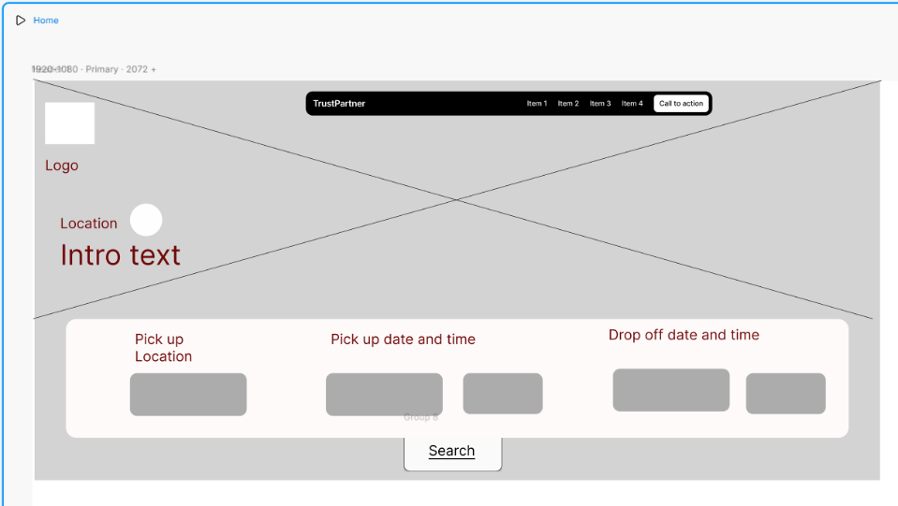
Index page:
Figure 1: Index page
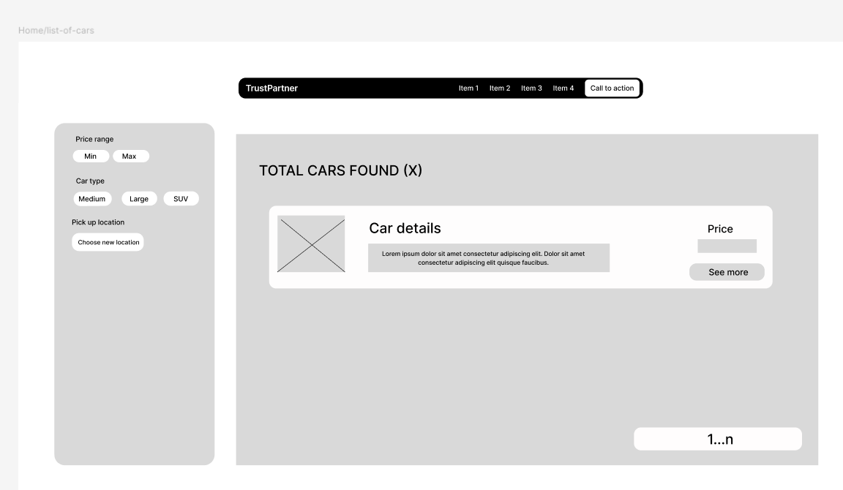
Figure 2: List of all available cars.
After the user sends a search request (Figure 1) the system redirects the user to the view page of all available cars with a short description and pagination.

Class diagram
For making the class diagram, the tool Draw.io was used.
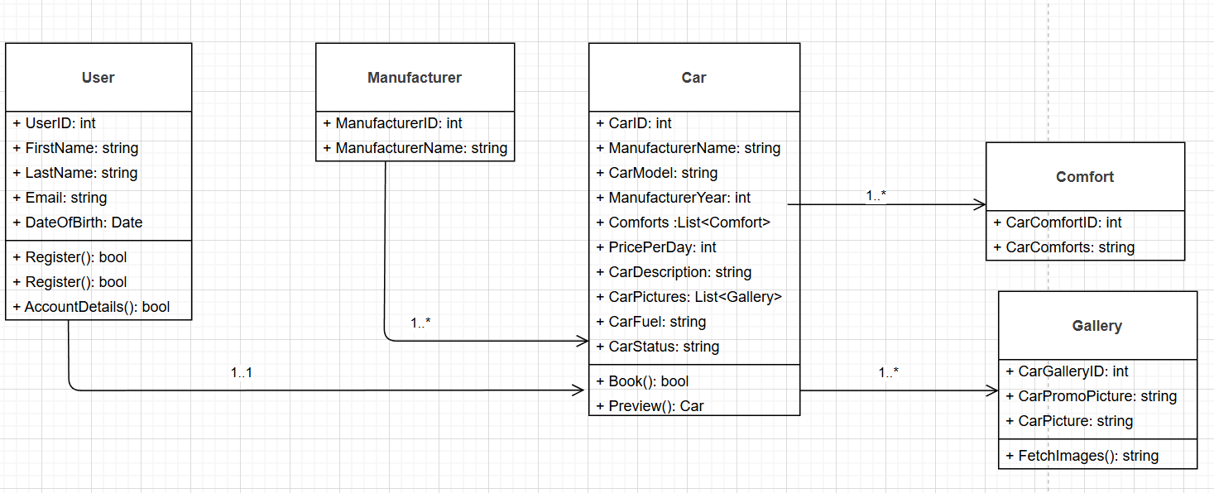
Figure 3: UML class diagram

ERD diagram
For the ERD diagram, MSSQLServer Manegement Studio was used (database-first approach).
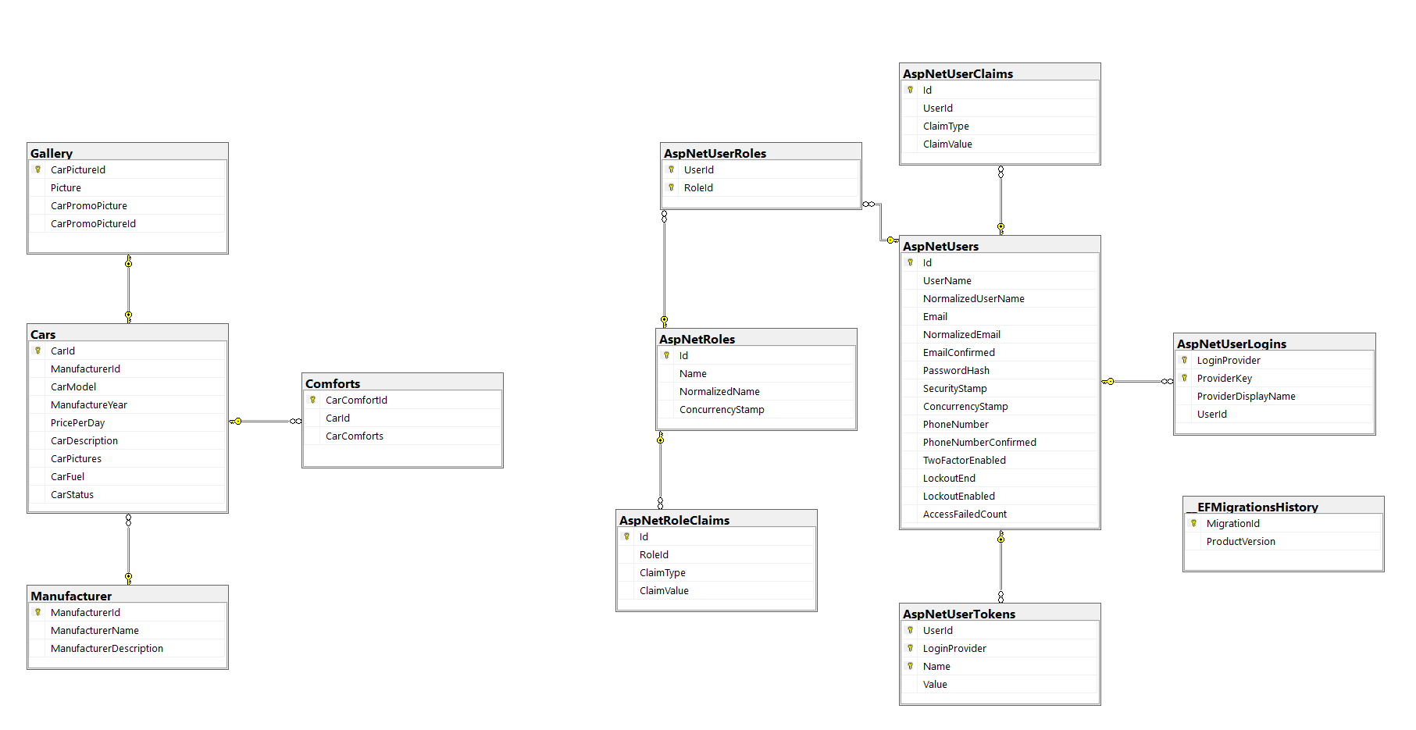
Figure 4: ERD diagram

